**CHAPTER 4** page: 5 to6

2. Design and Specification

2.1 Design Phase

In design phase the project requirements converted into detailed and complete design system. It represents the design criteria that use before the designing of project and target parameters of data that used in the project. It helps in understanding of what to build and how it expected to build. It represents the design diagrams of the project like use case diagram, conceptual and activity diagram etc.

2.1.1 Synopsis

Synopsis represents the database design synopsis. It represent the database tool it is used to search and generate reports and to add, edit, delete and select data using database. In society voting application firebase database is used. It is android online database it has real-time database and have the built in feature of OTP (One Time Password).

2.2 conceptual diagrams

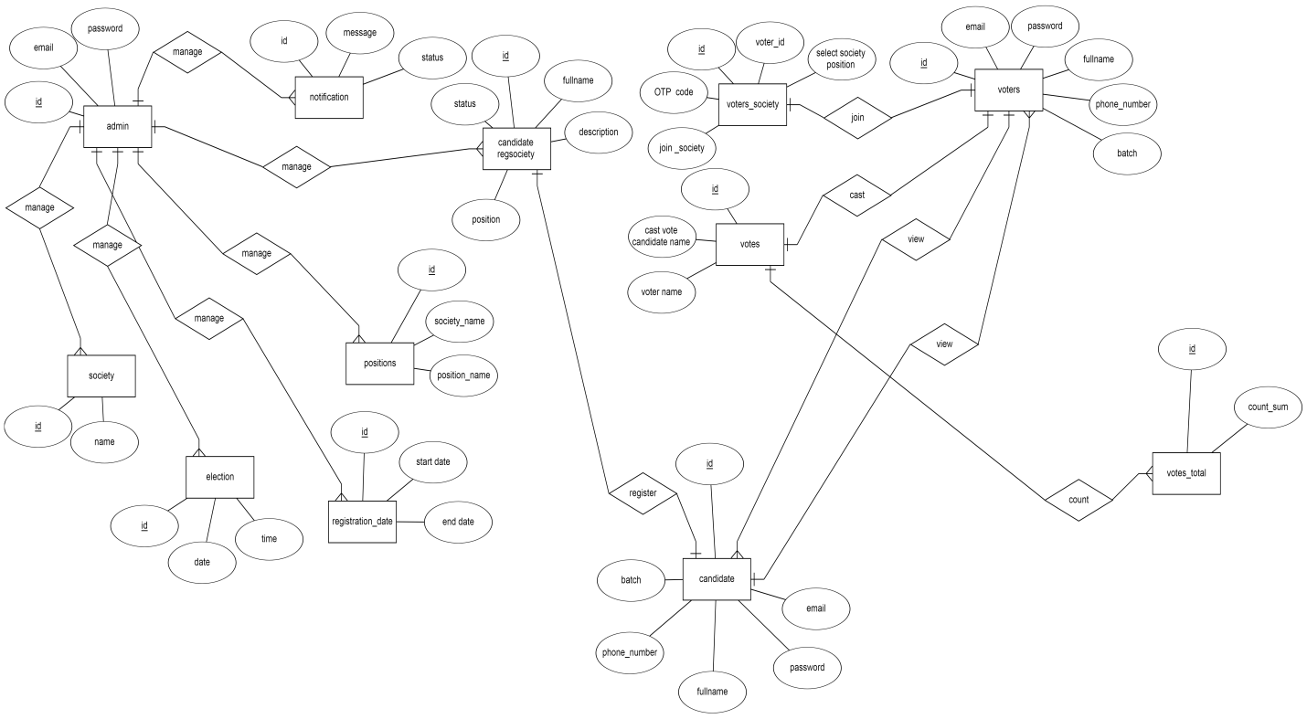

2.3 low level design

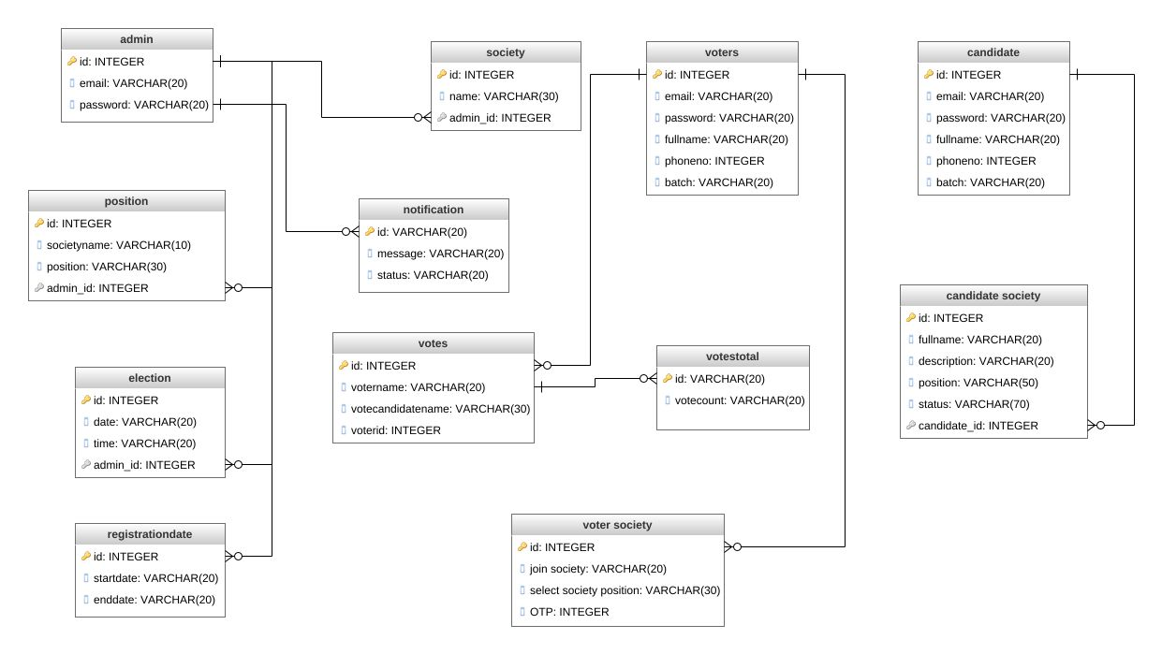

2.4 use case diagram

Admin and voter use case

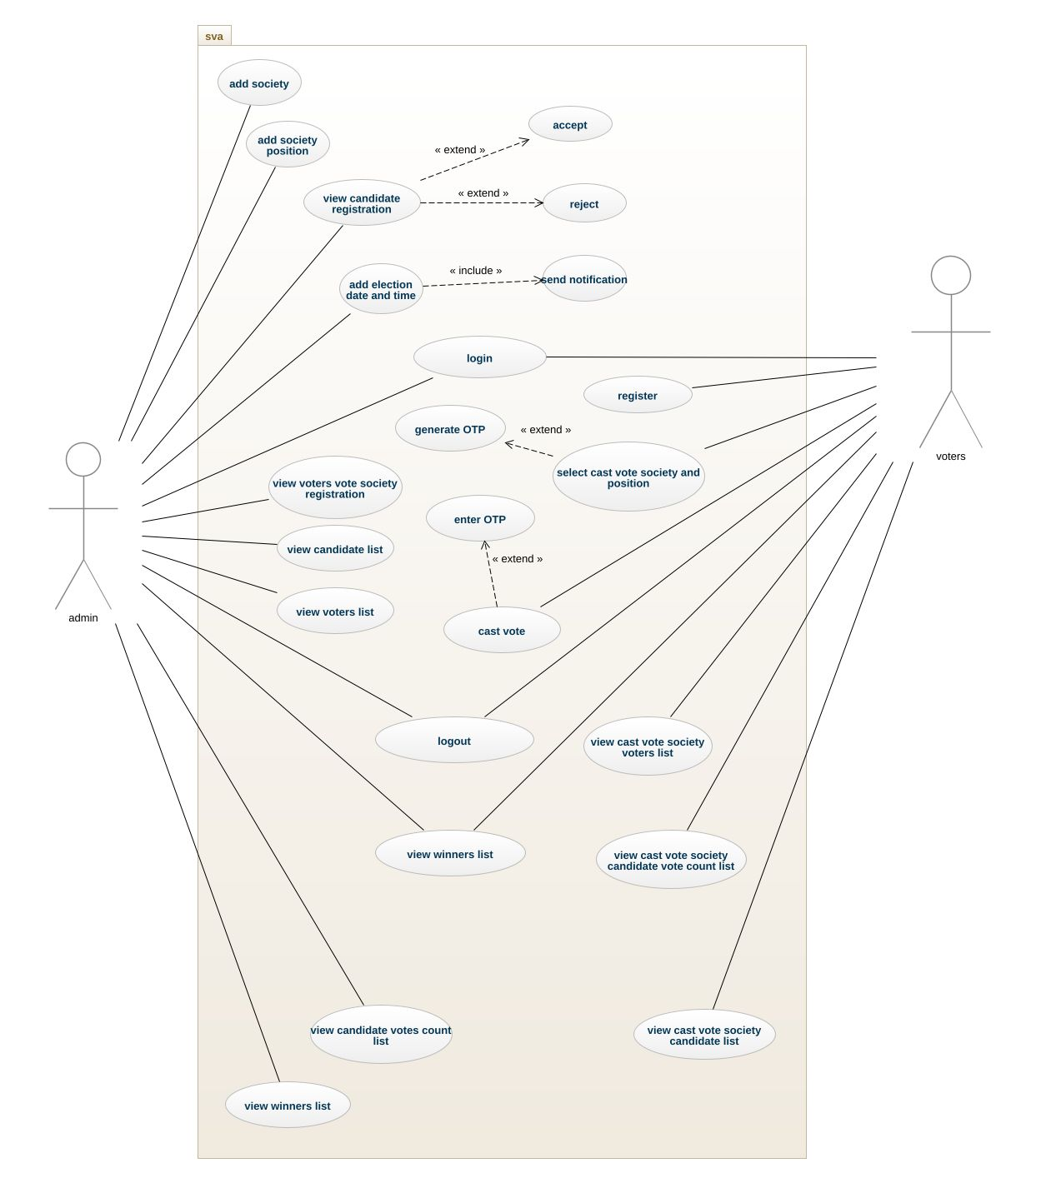

Candidate use case diagram

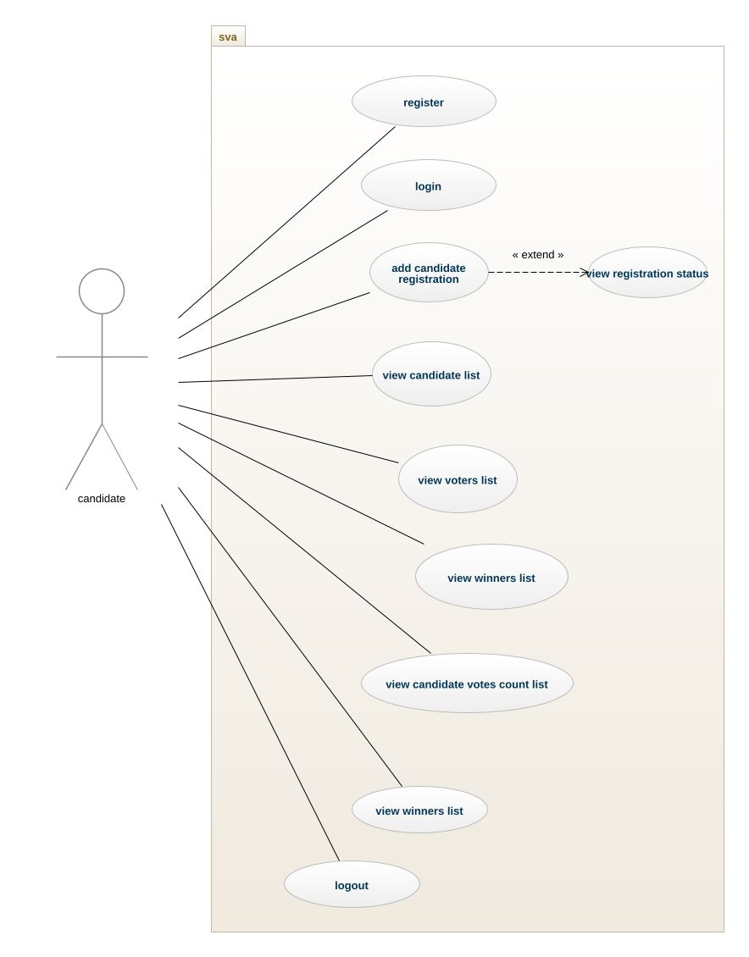

2.5 Activity Diagram

Voter interface activity diagram

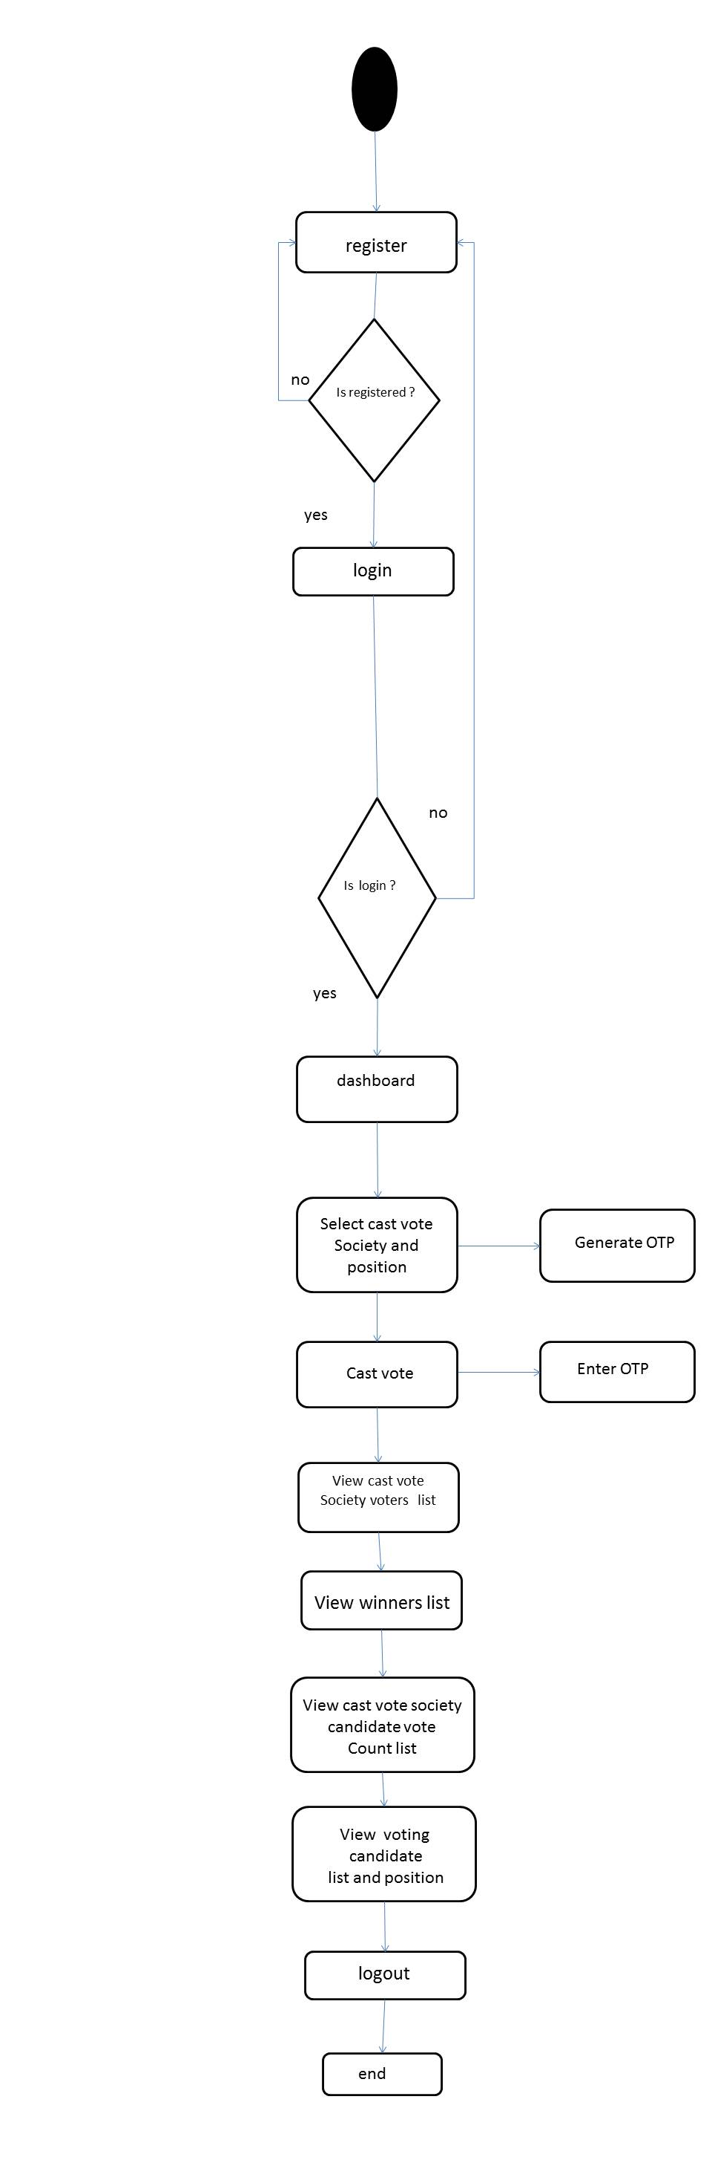

Candidate interface activity diagram

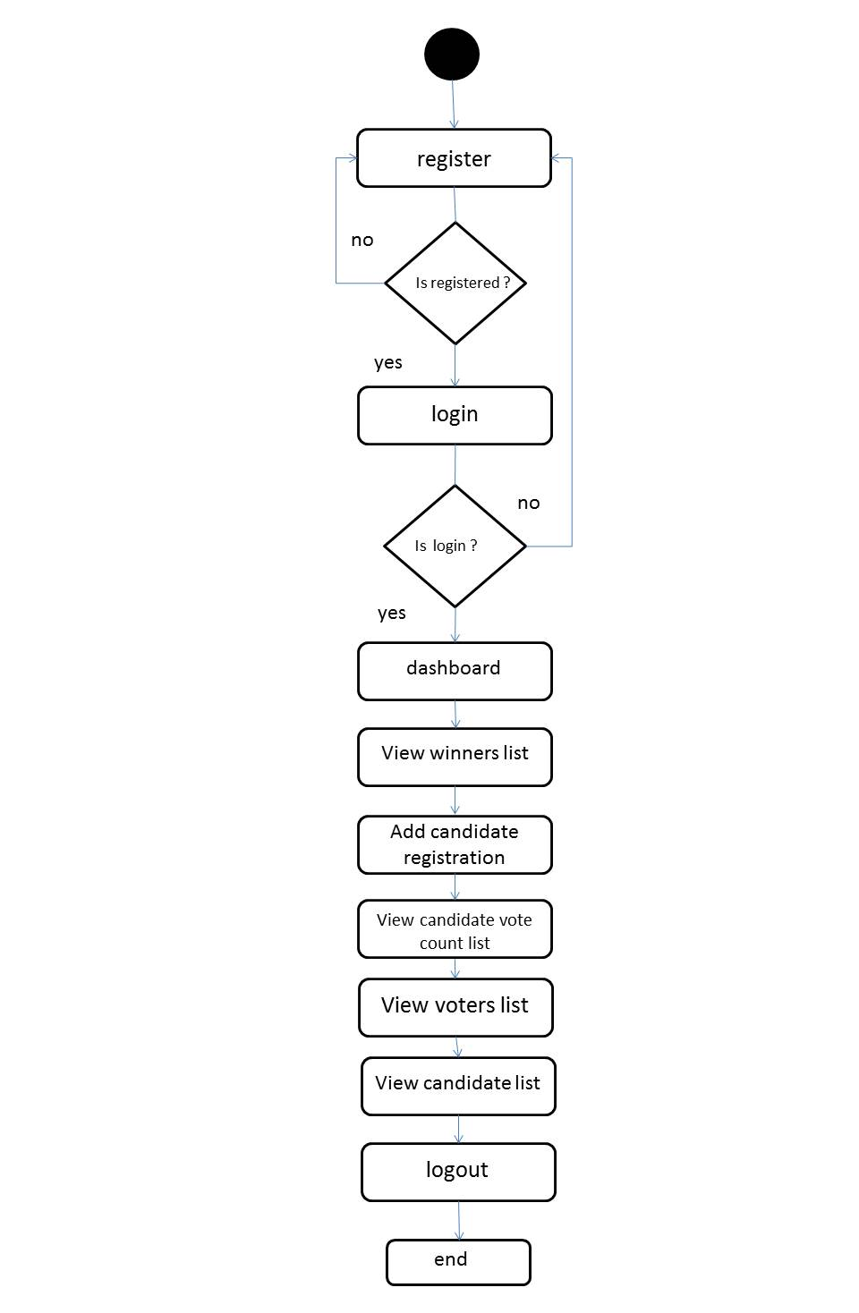

Admin interface activity diagram

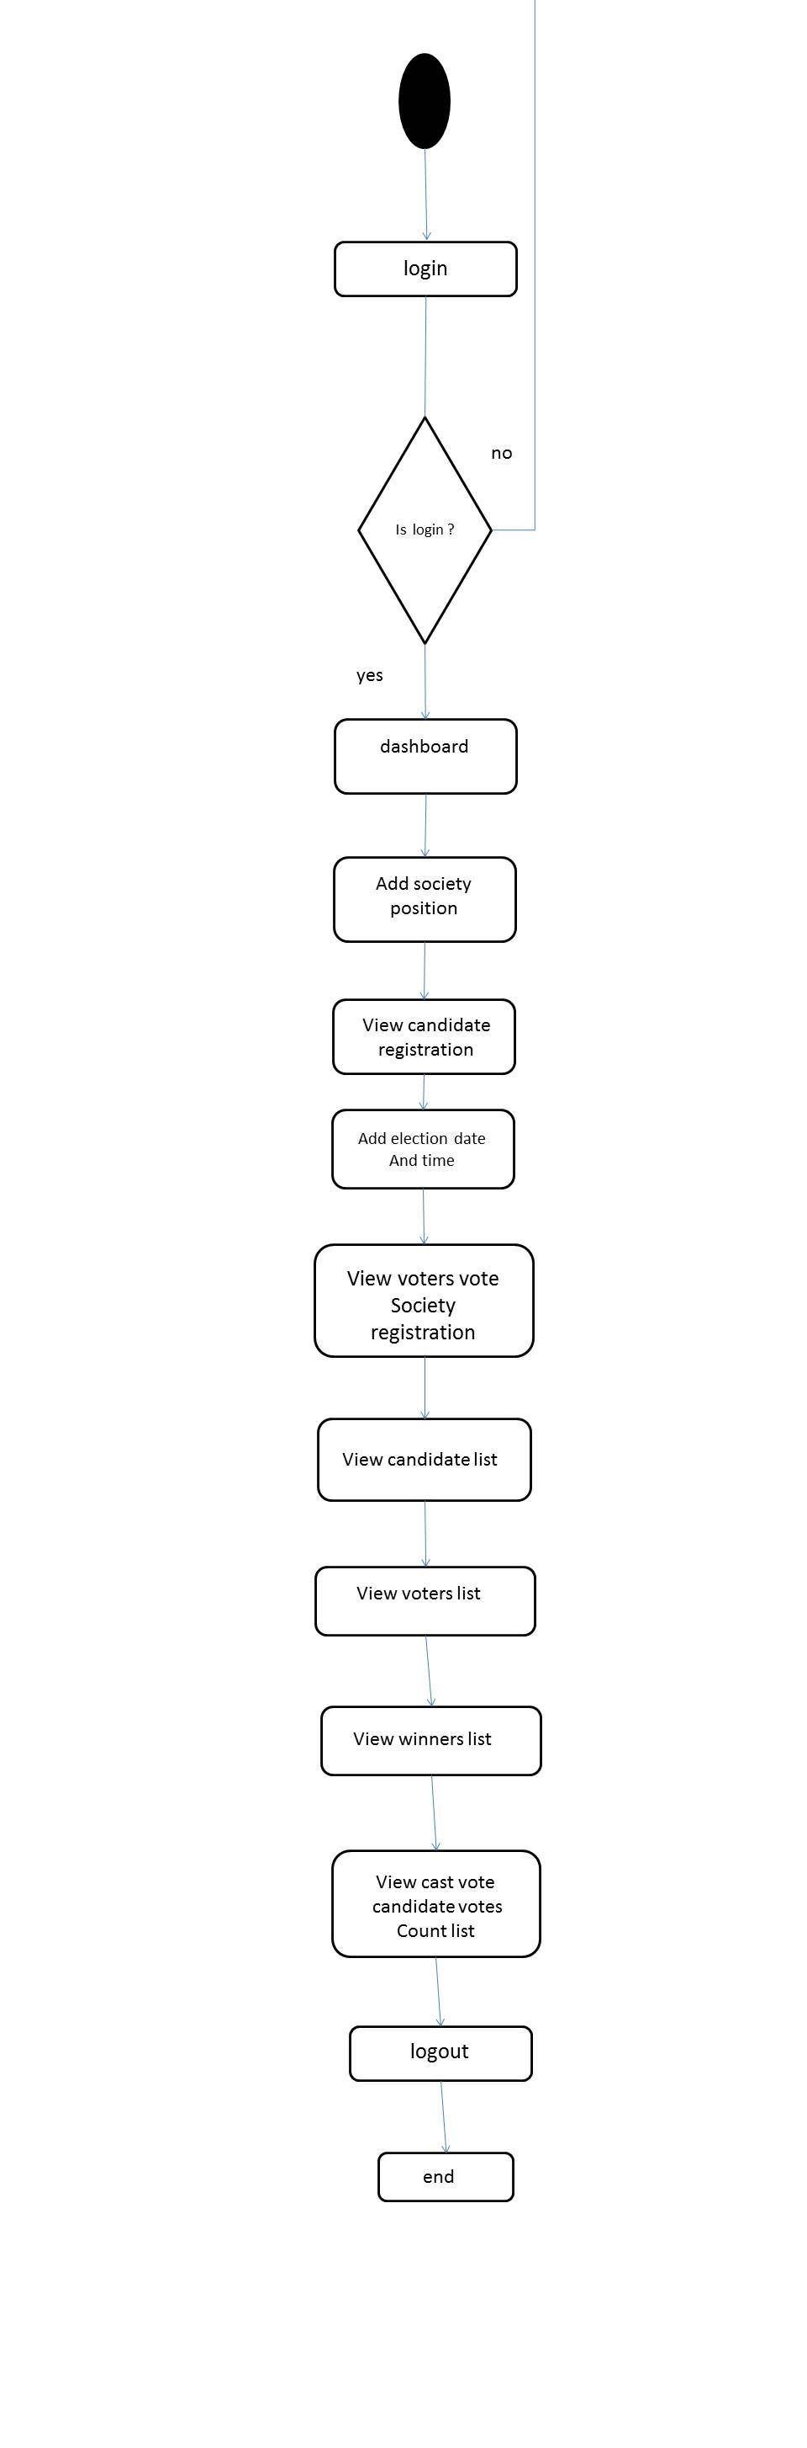

2.6 discussions related to diagrams

* Conceptual Diagram : conceptual diagram is an entity relationship diagram it shows the entity of the project those data stored in the database.it represent entity using square which will be table name and the entity has attribute which is represent by oval which will be table column name.
* Low level diagram: it shows the table of the database and column of table and what type of data stored in each table column. It also represents the primary key of each table. It represents the table and table column and data stored in the database.
* Use case diagram: it shows the functionality of the system and the type of users who use the application. The human symbol represent user of the application. Oval represent the functionality of the system and line shows the association of the user with functionality it shows which user can use which functionality of the system. Square represent the system
* Activity diagram: activity diagram shows the flow of the activity. Who the flow moves from one activity to other. It also shows the complete flow of the activity from starting to end and it also shows the condition of the activity if this happens then where flow moves. Circle shows the starting point of activity. Square shows the activity name and arrows shows the direction of flow of activity and diamond shows the condition of the flow.